COMPARISON OF THE GREULICH AND PYLE TECHNIQUE VERSUS THE TANNER AND WHITEHOUSE TECHNIQUE IN THE EVALUATION OF SKELETAL AGE IN LATE PUBERTY

Opinion by Assoc Prof Vincent Low, 9 March 2012

PHYSIOLOGY OF THE SKELETON
The adult human skeleton is comprised of 206 individual bones. Each individual bone develops during the first two decades of life in a genetically determined sequence of events. All bones begin as foci of cartilage which is invisible to x-ray. As the bone develops, it calcifies and becomes visible to x-ray. There are two types of bone shapes that are relevant to our discussion; ‘small bones’ and ‘long bones’. As ‘small bones’ develop, they become larger and change shape, conforming to the shape of their neighbours.

‘Long bones’ also enlarge as they develop. In addition, they also develop caps (my own colloquial descriptive term) at usually one end, sometimes both ends. The main central section is correctly described as the diaphysis, its popular name is the ‘shaft’. The newer ‘cap’ at the end is called the epiphysis. Between these two bits of bone is a structure known as the ‘growth plate’. In the development of the long bone, the ‘shaft’ enlarges. The ‘cap’ also enlarges and changes shape to conform to the adjacent ‘shaft’ and other neighbouring bones. The ‘growth plate’ is initially made of cartilage and is invisible to x-ray and therefore appears as a black line between the cap and the shaft. Towards the final stages of the development of a long bone, the cartilaginous growth plate slowly changes to bone. In that process, the cap becomes firmly attached to the shaft. On x-ray, the change is recognizable as the black cartilage gives way to white bone. The black gap between the cap and the shaft changes to a white line which then disappears.

RADIOGRAPH OF THE HAND
Taking a radiograph (x-ray) of a hand is a well recognized tool to study the skeletal development of a child. There are 29 bones in the area of interest providing a lot of information.

The hand is peripheral and small, therefore an x-ray can be acquired with a very small dose of radiation. To clarify this issue, radiation is measured in microsieverts (uSv). In the world we live in, we are exposed to about 2,000 uSv per annum as normal background radiation. The dose from an x-ray examination of the hand is about 0.1 uSv. This is equivalent to about half an hour of background radiation. In comparison, a chest x-ray is about 20 uSv, a mammogram is about 700 uSv, and a body CT scan 5 to 10,000 uSv (equivalent to 2 days, 2 months and 3 years of background radiation respectively)

GREULICH & PYLE
The developmental changes in these bones have been very well studied giving rise to several techniques to evaluate their normal or abnormal development. The reference book “Radiographic Atlas of Skeletal Development of the Hand and Wrist” by W.W. Greulich and S. I. Pyle (“G&P”) is the standard guide by which such a determination is made. I refer to this reference book in order to determine the skeletal age of a subject. Age is determined by comparing the x-ray of the individual with the comprehensive studies in this text that have resulted in statistical standards of skeletal development. These standards are currently used worldwide, although they were developed from studies carried out in the United States and United Kingdom in the late 1950s. It was and remains to today the most exhaustive study of its kind with 6,879 radiographs and at least 100 cases of each age. All radiologists that I am in communication with around Australia and around the world use this same Atlas.

The Greulich & Pyle (G&P) method of analysis of a child’s skeletal age is not considered a difficult interpretation. It is taught to all trainee radiologists. Any radiologist can look at a hand radiograph, compare it with standards in the Atlas and render an opinion. When any radiologist renders a report on the hand radiograph of the subjects of interest to our Court, the reports are similar because there is very little to vary. The observation is that the growth sites have all fused indicating an appearance of skeletal maturity. All our subjects have hand xrays which show skeletal maturity which radiologists in practice recognize as occurring at age 19 years (G&P standard 31). The radiologist will then go on to say this indicates the subject is probably 19 years of age or older. Please note that G&P standard 30 male age 18 years is described as close to but not quite achieving maturity. If this expert opinion was all the Court had to make a decision, the only decision possible would be that the subject is an adult over 18 years of age. My opinion and testimony introduces a realistic appraisal of the possibility of the subject being less than 18 years of age due to the normal variation in human physiology.

This is where there is confusion in the use of terminology to discuss this matter. The terms “Fusion” and “Maturity” are used in similar but critically different ways by radiologists using G&P versus practitioners who use Tanner & Whitehouse (TW3) as presented by [name].

INTERPRETATION OF TW3 BY PROFESSOR COLE
When I evaluated [name]’s statistics, his figures translate to an average age of skeletal “maturity” of 17 ½ years, an advancement of 1 ½ years compared with 19 years which is what I and other radiologists accept and what is indicated by Greulich and Pyle. This is an extraordinarily large difference, all the research studies have indicated variations in the order of a few weeks to months. Therefore, this large incongruity does not make any scientific sense.
I then studied the Tanner & Whitehouse technique and conclude that it is measuring a different event compared with G&P when it comes to FINAL maturity. G&P male standard 31 describes completion of skeletal maturity in all the bones of the hand. TW3 gives a numerical score at each of the studied bones of the hand and wrist. At each location, the stages of development are described in detail and divided in to 8 or 9 stages (A to I). This method is very useful when it comes to the developing bones as there is a lot of change happening to a lot of bones. Very useful in clinical practice as this is the stage when detection of growth disturbance is useful and treatable. The analysis relevant to our cases before the courts has a very different interest.

COMPARISON OF G&P WITH TW3 AT “MATURITY” AND “FUSION”
This illustration from TW3 shows the stages B to I. Stages B to H involve changes in the shape of the epiphysis (the cap). Throughout these stages, the gap or line between the two pieces of bone remains black because it remains cartilage.
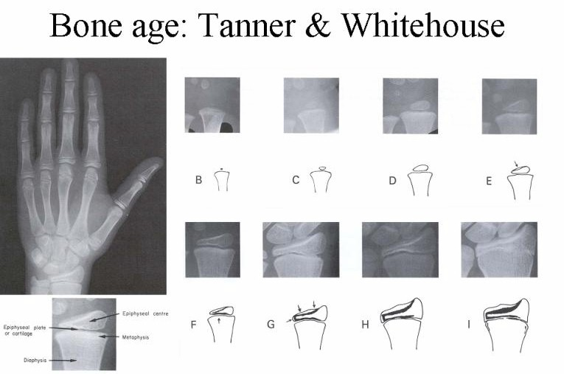

The last stage ( I ) is NOT described as complete fusion but instead is described (see page 63 of the TW3 book) as an entire event “Fusion of the epiphysis and metaphysis has begun. A line may still be visible, composed partly of black areas where the epiphyseal cartilage remains and partly of dense white areas where fusion is proceeding; or the line may have disappeared.”
Visually, stage I involves the black line (of cartilage) changing to a white line (of bony fusion). The line then proceeds to disappear.
This process is not an instantaneous event and must take a certain amount of time to occur.

Referring back to G&P we find that this spans across male standards 29 to 31, age 17 to 19 years.

Here is a detail of the radius bone from G&P male standard 28, age 16 years, page 117.
Note the appearance of the black line at this age.

Here is a detail of the radius bone from G&P male standard 29, age 17 years, page 119.
Visually, the black line persists. The accompanying description on page 118 talks about changes in the other bones of the hand, there is no mention of a change in the radius.

Here is a detail of the radius bone from G&P male standard 30, age 18 years, page 121.
Visually, the black line has partially changed to a white line, with remnants of a black line seen on the edges of the bone. If we now refer back to the TW3 description of stage I, we see stage I has now commenced and so would be calculated by the TW3 technique as receiving a stage I score. Since all the bones in the hand have now reached stage I, this would receive a TW3 score of 1,000 and recognized as skeletal maturity.

Furthermore, since the conversion of the black line to white line is quite advanced, this indicates that the process of change had begun several months ago midway between the ages of 17 and 18 years. Similarly, TW3 stage I has also commenced several months ago. This is in agreement with [name]’s calculation of skeletal maturity (TW3 score 1,000) occurring at 17 ½ years.

Here is a detail of the radius bone from G&P male standard 31, age 19 years, page 123.
Visually, the black line has totally disappeared. The white line also disappears although in about a third of people, there is a residual partial white line as shown in this representation.

Referring back to TW3, this is still stage I. This point of development is what radiologists recognize as “fusion” and skeletal “maturity”.

Therefore by my study of both techniques, I conclude that TW3 stage ‘I’ takes between one and two years. This then explains why [name]’s statistics indicates a “mature“ age of 17 ½ years, he is measuring the age at which this stage (stage “I”) of fusion BEGINS. This is clearly different from the G&P standard 31 which tells us when this stage of fusion finally ENDS.

CONCLUSION
I have uncovered the reason for the discrepancy in the opinions between [name] using TW3 and radiologists who use G&P. [Name] is actually validating G&P’s assertion that FINAL fusion occurs at age 19 years as I contend.

Assoc Prof Vincent Low FRANZCR
9 March 2012

